CURRICULUM VITAE

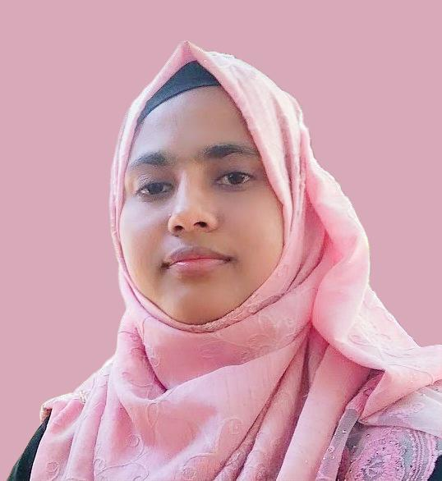
Tasmin Jannat Tahsin
Phone : +8801645966568
Email : tahsinyea183@gmail.com
GitHub :
Linkedin :
Address : Avenue 5,Modhina Nagar, Mirpur 11,
Pollobi ,Dhaka- 1216, Bangladesh.

Career Objective

Enthusiastic and dedicated Software Quality Assurance (SQA) graduate seeking an entry-level position to utilize my knowledge of software testing principles, quality assurance processes, and bug tracking techniques. Passionate about maintaining software quality, improving user experience, and supporting organizational success through effective testing practices.

Scholastic Record

Exam Title | Group/Subject | Institute | Board | Result | Passing Year
BSC | Computer Science and Engineering | Green University Of Bangladesh | Dhaka | CGPA: 3.70 out of 4 | 2022
HSC | Science | Kapasgula City Corporation Mohila College | Chittagong | GPA: 4.43 out of 5 | 2017
SSC | Science | Kutubdia Govt. Girls’ High School | Chittagong | GPA: 5.00 out of 5 | 2015

Skills

Testing Tools:
● Manual Testing: Requirement Analysis, Test Planning, Designing, Writing and Reviewing Test Cases, Test Execution and Evaluation, Creating Test Report, Root cause analysis & Bug Reporting using test management tools.
●WEB Automation: Java, Selenium, Playwright, Appium, Cucumber, Jenkins.
● API Testing: Postman, Newman & Rest-Assured
● Performance Testing: JMeter
● Agile & Project Management: JIRA
● Database: MySQL
● Programming: JAVA and C
● Source & Version Control : Git & GitHub

Fundamental Concepts:
● Software Development Life Cycle (SDLC)
● Software Testing Life Cycle (STLC)
● Object-Oriented Programming (OOP)

Project

Manual Testing:
• Test Case Writing
Link: GitHub
• API Testing Using Postman & Newman
Link: GitHub
• Performance Testing Using JMeter
Link: GitHub

Automation Testing:
• Web Automation: Selenium
Link: GitHub
• Web Automation: Cypress
Link: GitHub
• API Automation: Rest-Assured
Link: GitHub
• Database Automation: MySQL
Link: GitHub

Training

- Full Stack SQA (May,2026 to September,2026)
- IT Training BD, a United States based training organization.
- Fb Link: https://www.facebook.com/It-Training-Bd-211709726924087

Achievements

- Get VC and Dean’s Award Certificate in several time in university life.
- Accepted and presented thesis paper in 2022 4th international conference on STI 4.0 and getting a certificate of contribution
References

Sabiul Islam Rashed
SQA Head, Burnsys, Dubai, UAE
Email: 234sabiul@gmail.com

